**Foundation**

SQL

Module 9

Aggregate Functions – Query reading

© FDM Group Ltd 2017. All Rights Reserved.

Any unauthorised reproduction or distribution in part  
or in whole will constitute an infringement of copyright.

**Document change and version control**

|  |  |  |  |
| --- | --- | --- | --- |
| **Reason for Change** | **Author** | **Date of Change** | **New Version No** |
| Creation of document | Nick Lawton | 26/06/2017 | v1.0 |
| Two mistakes in question 5 rectified:   1. COUNT(number_called) changed to COUNT(number_texted). | Nikola Ignjatovic | 26/05/2020 | v1.1 |
| A mistake in question 6 rectified: the query groups records by customers’ name, thus if there are more customers with the same name it would calculate the number of mobile phones for all of them together, rather than separately. The problem is fixed by including the customer_id to both SELECT and GROUP BY clauses. | Nikola Ignjatovic | 21/07/2021 | v1.2 |
|  |  |  |  |
|  |  |  |  |
|  |  |  |  |
|  |  |  |  |
|  |  |  |  |
|  |  |  |  |
|  |  |  |  |
|  |  |  |  |
|  |  |  |  |

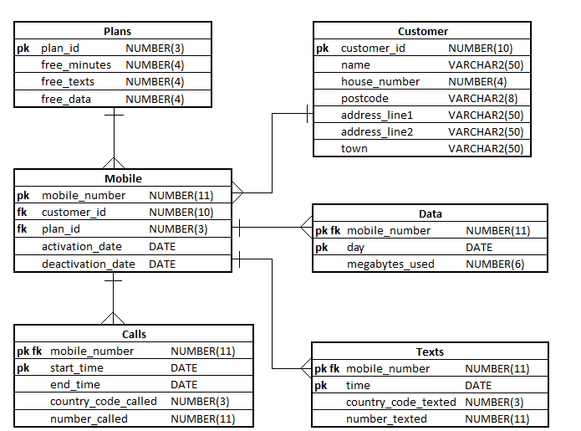

**Exercise 1**

## Describe in simple language what each of the following queries will return:

|  |
| --- |
| **Questions** |
| 1. SELECT AVG(megabytes_used)   FROM data; |
| 1. SELECT mobile_number,   COUNT(*)  FROM calls  GROUP BY mobile_number; |
| 1. SELECT mobile_number,   SUM(megabytes_used)  FROM data  GROUP BY mobile_number; |
| 1. SELECT mobile_number,   TO_CHAR(day,’YYMM’)  SUM(megabytes_used)  FROM data  GROUP BY mobile_number, TO_CHAR(day,’YYMM’); |
| 1. SELECT mobile_number,   COUNT(number_texted)  FROM texts  WHERE TO_CHAR(time,’YYMM’) = TO_CHAR(SYSDATE,’YYMM’)  GROUP BY mobile_number; |
| 1. SELECT c.customer_id,   c.name,  COUNT(m.customer_id)  FROM customers c  INNER JOIN  mobiles m  ON m.customer_id = c.customer_id  GROUP BY c.customer_id,  c.name; |
| The following queries either produce an error, meaningless or pointless output.Explain which is which:  1. SELECT mobile_number,   number_called,  COUNT(number_called)  FROM calls  GROUP BY mobile_number; |
| 1. SELECT plan_id,   MAX(free_minutes)  FROM plans  GROUP BY plan_id; |

1. SELECT AVG(megabytes_used)

FROM data

GROUP BY mobile_number;